**About Myosoft**:

Myosoft is an ImageJ-based macro that can be used for near-autonomous muscle fiber size and type analysis. Myosoft is freely available for download here. Myosoft is designed to be user-friendly while also retaining some ability for user input, specifically with regard to morphometric gates that the macro uses to identify objects of interest (e.g. muscle fibers). Therefore, the user will receive several prompts when the macro is run.

Myosoft is built to handle (up to) 4 channel images, with a membrane counterstain on 1 channel, and myosin heavy chain isoforms (or other intracellular proteins) on the remaining 3. By default, Myosoft will prompt the user for the channel number corresponding to the counterstain, type IIa, type I, and type IIb fibers (more detail in section 10). If you are not using all 4 channels, simply provide the numbers for the channels you are using and leave the others blank. Myosoft will still “analyze/provide results” for blank channels, but in actuality, it is just duplicating analysis of channel 1, and the data for these duplicates can be ignored.

**\*Note:** the channel names are only names. They do not affect the analysis in any way, but the results will be stored in .csv files that bear the names of the channels. If you are not staining typeI, typeIIa, and typeIIb fibers, we would recommend running Myosoft with these default labels and simply keeping track of which of those labels corresponds to each of your real stains. It is possible to change the names within the code, but that process is slightly complicated.

What outputs will Myosoft give you? See the results section below for a detailed description. Briefly, you will get individual channel images with “fiber” ROIs overlaid, a .csv (Excel compatible) results file for each image channel that includes all measurements taken by Myosoft, and a color-coded version of the input image where fibers are pseudo-colored according to CSA (a scale bar is also saved in the results, showing the colors assigned to fibers of various sizes).

If you would like to adapt the Myosoft code for a new application, the macro can be edited in FIJI **Plugins>Macros>Edit>Myosoft.ijm** (select the .ijm file from its source folder). The source code is annotated by the author in the interest of clarity.

**Requisites for Myosoft**

* FIJI (Fiji Is Just ImageJ) version 2.0 with Java 1.8 or newer
  1. The version can be checked in the Fiji application
  2. 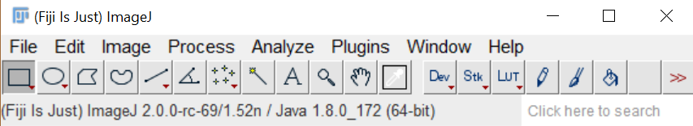
  3. The latest version can be downloaded from <https://imagej.net/Fiji/Downloads>
* Trainable Weka Segmentation (TWS) v3.2.33
  1. This should come with the latest FIJI download and can be found in **Plugins>Segmentation> Trainable Weka Segmentation**
  2. Version of TWS can be found at the top left corner of the window
     + 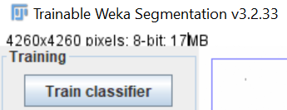
* BioVoxxel Watershed Irregular Features
* Biovoxxel Extended Particle Analyzer
  1. Both can be downloaded by adding the BioVoxxel update site
  2. **Help>Update>**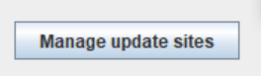
* Note: when selecting “Update” from the “Help” menu, FIJI will automatically run an updater. The user must wait for the updating to complete (usually a few minutes or less) before the option to “Manage update sites” is displayed.
  1. Select the BioVoxxel update site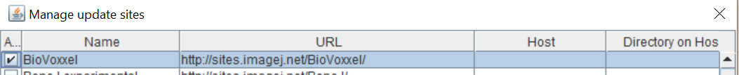
  2. **Close>** 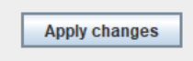
* Bar Color Coder
  1. This can also be downloaded by adding the BAR update site using the steps outlined above but clicking the BAR update site.
     + Note: BAR is a suite of plugins with a variety of functionalities. Once the BAR update site is enabled, “BAR” will appear above the toolbar in the primary FIJI menu.

**Using Myosoft – Windows and Mac**

- Download and initialization

1. Save the Myosoft Hub folder to an easily accessible location
   * The directory should be C:\Myosoft Hub for Windows, Document/Myosoft Hub for Mac
   * A number of subfolders are included in the parental “Myosoft Hub” folder. These are populated when the macro runs. Any file generated in these folders will be overwritten every time the macro is used **unless you make subdirectories within them for each image you analyze (see step 5, below)**.
2. When a multi-channel image is opened in FIJI, the bio-formats Import Options window will open. Open your image as a hyperstack, and do not split channels (see red circles below). Myosoft will automatically split the channels.

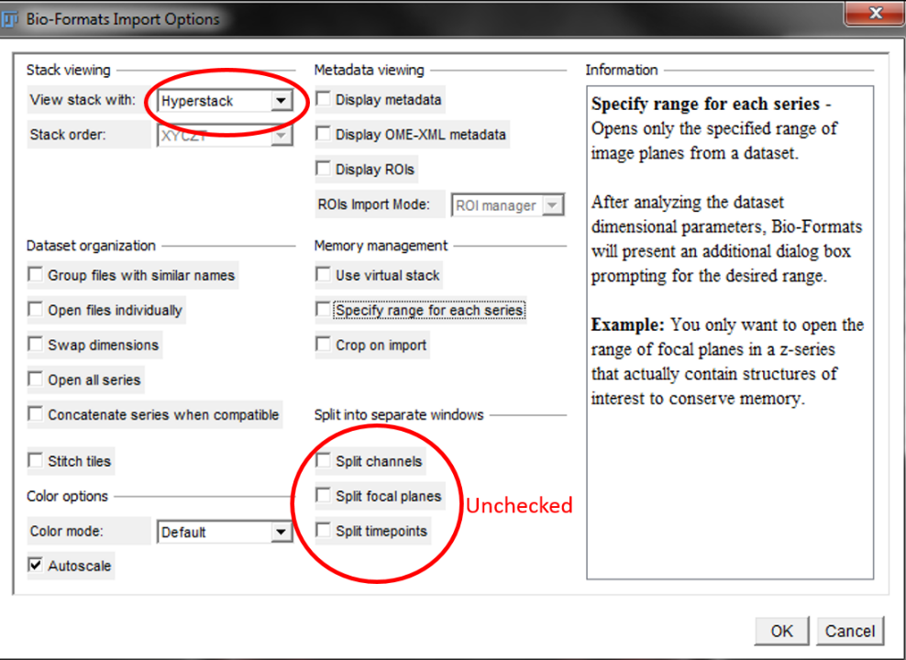

* + **If you are opening single channel images** **rather than an already merged image**, they will need to be made into a hyperstack before running myosoft.
  + Make sure that your single channel images are 8- or 16-bit (NOT RGB images). You can merge them by going to Images -> Color -> Merge Channels, or by going to Images -> Stacks -> Images to Stack.
  + Once you have a composite, go to Images -> Hyperstacks -> Stack to Hyperstack. At this point, you are ready to begin.

1. Open the Myosoft v 6.0.ijm code by dragging it into FIJI or by going to **Plugins>Macros>Run>Myosoft.ijm**.
2. Click Run. You will receive several prompts. **It is highly recommended that you know the scale of your image (pixels per micron) before running Myosoft.** You will be asked to supply this value in Step 8.

- User interaction steps: What does Myosoft require from you?

1. You will now be asked to specify two kinds of locations: first, you will also be asked to specify the location of the primary and iterative classifiers that Myosoft uses to perform image segmentation. The classifiers are in a subfolder of the parental “Myosoft Hub” folder called “1, 2 - Classifiers.” You will also be asked for a location to save various images that are generated as the macro runs.
   * Most of these images are generated by Myosoft and are simply processed versions of the input image. As such, it is unnecessary to keep them permanently, but you may wish to do so for your own records.
   * An ROI mask, indicating objects that Myosoft identified as myofibers, is placed over the original input image (for each channel) and saved (example, membrane counterstain = “InputImageNameHere_referenceImg_area”). The number associated with each ROI will match a number in an Excel spreadsheet generated by Myosoft, which contains all of the measurements taken for that ROI/myofiber. This is the most useful image generated by Myosoft as it allows you to audit your data.
   * It is recommended that you choose individual subfolders for each type of image you are prompted to save, and for each input image you analyze with Myosoft. This will ensure that none of your files are overwritten by accident.
     + 1. Primary classifier location: this is the location of the primary classifier. It is NOT a location where anything will be saved. The classifiers are in a subfolder of the parental “Myosoft Hub” folder called “1, 2 - Classifiers.” If you moved this subfolder, if you moved the classifiers to a different folder, or if you are not using the classifiers provided with Myosoft, you must choose folder in which the classifier you which to use is stored.
       2. Iterative Classifier location: this is the location of the iterative classifier. It is NOT a location where anything will be saved. The classifiers are in a subfolder of the parental “Myosoft Hub” folder called “1, 2 - Classifiers.” If you moved this subfolder, if you moved the classifiers to a different folder, or if you are not using the classifiers provided with Myosoft, you must choose folder in which the classifier you which to use is stored.
       3. Single Channel Images: as mentioned above, Myosoft will split a multi-channel image into its component channels. The single channel images will be saved. You may choose where. We recommend creating a subdirectory in the folder “3 – Single Channel Images”.
       4. Convolved Images: A convolution is used to blur object boundaries and reduce noise. This is a standard processing step. Convolved images are saved. You may choose where. We recommend creating a subdirectory in the folder “4 – Convolved”
       5. Segmented Images: The primary classifier will perform an initial round of segmentation. Segmented images are saved because these images are then used as the input for the iterative classifier. You may choose where. We recommend creating a subdirectory in the folder “5 – Segmented Images”.
       6. Iteratively Segmented Images: Segmented images (from 6e) are run through the iterative classifier to provide enhanced segmentation accuracy. The images generated after iterative segmentation are saved and then stitched together to re-form the input image (you can read more about slicing/stitching in section 8). You may choose where the iteratively segmented images are saved. We recommend creating a subdirectory in the folder “6 – Iteratively Segmented Images”.
       7. Fused image location: after the primary and iterative classifiers run, the sliced, iteratively segmented images are re-stitched. This is a binary, processed version of the membrane counterstain channel of the original image. It is saved. You may choose where. We recommend creating a subdirectory in the folder “7 – Fused Images”.
       8. Data location: Several measurements are made as Myosoft runs. They are saved in a series of Excel files. Images of individual channels with fiber ROIs overlaid as a mask are also saved (see below). You may choose the location. We recommend creating a subdirectory in the folder “8 – Data”.

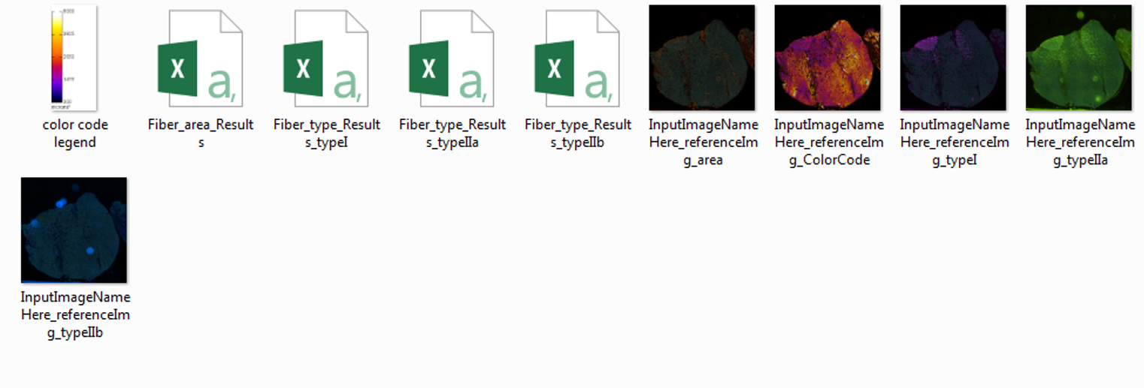**Above**: Data folder contents.

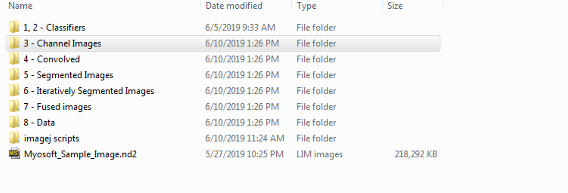

**Above**: Default Myosoft directories. **Below**: Example subdirectories for each sample.

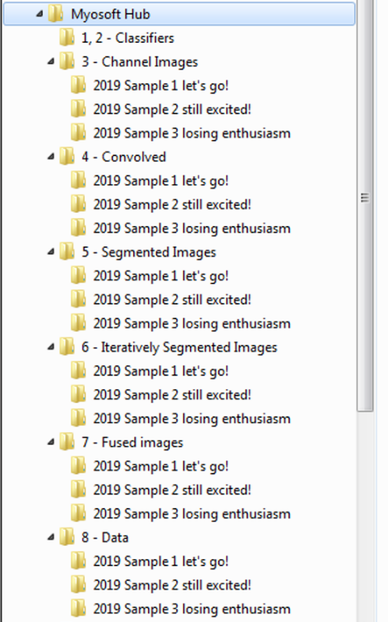

1. Morphometric gates

* Myosoft uses the Extended Particle Analyzer in the BioVoxxel Toolbox to set a number of “gates,” or exclusion criteria for objects that are classified as myofibers but are probably not or are myofibers, but in an improper orientation. For example, the minimum area gate would exclude small blood vessels or nerves, while the maximum area and circularity gates would exclude oblique or longitudinal myofibers within the section.
  + - * 1. Min/Max area – default range is 300-13000µm2. Ideally, this range should be tested on a control section, and small and large values should be examined to ensure that these gates are appropriate for your sample. As a general rule, fibers of ~5000µm2 are quite large and appear at the upper end of ranges reported in the literature.
        2. Min/Max circularity – Circularity = ; a two-dimensional area:surface measurement. For a perfect circle, this value would be 1.
        3. Min/Max solidity – Solidity = ; in other words, what is the ratio of the true area of your object to the area it would have if it were imagined as a convex polygon (concavities extended outward)?
        4. Min/Max perimeter – measures the length of the object perimeter.
        5. Min/max minimum feret distance – minimum feret distance is the shortest possible distance between any two tangent lines of your object perimeter. For an ovoid shape, this would be the length of the short axis.
        6. Min/max feret AR – the aspect ratio (AR) of ferets for your object, that is, . For an ovoid shape, this would be the ratio of the axes.
        7. Min/max roundness – Roundness = ; this formula compares how closely your area matches the area of a perfect circle (value for perfect circle is 1).
* The Extended Particle Analyzer allows for more gates than those included as defaults in the Myosoft code. To view these, and to see some pictoral representations of the gates used, check [here](https://imagej.net/BioVoxxel_Toolbox#Extended_Particle_Analyzer).

1. A prompt will appear asking for an ROI expansion factor. The default value is 4 and this works well in our hands.
   * The binary, segmented images show what the classifier views as the probability that a given pixel in the image represents the boundary of an object (black p=1, white p=0). Typically, the classifiers will view several pixels at the cell boundary as plausibly marking the boundary, which is why the iteratively segmented images appear to have thick black borders around the fibers. ROIs denoting the fiber edges are drawn at the innermost edge of the probability map, which is usually well within the cell. ROI expansion moves the ROI outward in all directions by the number of pixels chosen with this prompt.
2. A prompt will appear asking you for the scale of your image. **IMPORTANT: you must know the scale (pixels per micron) of your image before running Myosoft.** If you do not supply the correct scale, then CSA values generated in Myosoft will not be in real spatial units. As a default, a value of 0.9091px/micron is provided, but it is likely that your image is scaled differently.
3. A prompt will appear asking you for Color Coder parameters.
   * Once Myosoft has completed fiber CSA analysis, it will automatically run an ROI Color Coder plugin (from BAR suite of plugins). This will provide a color-coded mask of your input image where fibers are assigned colors based on their CSA. This is an aid for visual inspection of your sample’s fiber CSA distribution, which is meant to complement a graphical representation of CSA values.

Minimum value – the lowest area value to which you want to assign a unique color. All objects below this value will receive the same color as the minimum. Default is 300, which is also the minimum area gate for objects.

Opacity – opacity value for colorization. The color-coded ROIs are overlaid on your original image (but saved under a different name), so if you wish to be able to see the original image objects, use a lower opacity value (that is, less than 50). Normally, this would be unnecessary, and a value of 80-100 will nicely mask your image.

Maximum Value – the highest area value to which you want to assign a unique color. All objects larger than this value will receive the same color as the maximum. Default is 4000

Color code – this is the LUT that will be applied to the data. The options are: Red Hot, Fire, Orange Hot, and physics.



Low values ------------------------> High Values

* The color-coded mask is saved in the location you chose for data (step 5h) as “InputImageNameHere_referenceImg_ColorCode”.

1. A prompt will appear asking for the position (within the hyperstack) of the counterstain channel, the type IIa, type I, and type IIb channels. 1 corresponds to the left-most position, and 4 corresponds to the right-most position. If you are not using 4 channels, leave any that you are not using blank.
2. A prompt will appear asking how many slices (divisions) you would like to make of your input image. The number you choose represents the number of slices in one dimension, so the square of the chosen number represents the total number of slices taken (e.g. input of 2 = 4 total slices, input of 4 = 16, etc.). **You must choose a value between 2 and 5,** but the default of 4 is recommended (5 if your computer has ~8GB RAM or less).
   * This step is included to guarantee that your machine has the necessary computing power for Myosoft to operate. Running large images through the classifier is resource intensive and inefficient. Instead, Myosoft will run 16 smaller images through the classifier consecutively.
3. When the macro is finished, a pop-up box will display the message “Analysis Complete.”

- Results

1. Myosoft will generate individual spreadsheets (.csv format) with data from each channel in the original input image.
   * The file from the membrane counterstain will be called “Fiber_Area_Results.”
   * Each of the other files will be named with the stained myosin heavy chain isoform in the title (e.g. “Fiber_type_Results_typeI”).
2. Myosoft will generate a series of reference images. The reference images are single channel images from the original input image with “fiber boundaries” and numbers overlaid as a mask. The number in each object corresponds to the same number in the data spreadsheets. These images are provided so that users can visualy inspect the objects from which measurements were taken by Myosoft.
3. Myosoft will generate a color-coded version of your input image where different colors indicate different sized fibers. A scale bar is also generated and saved in the location the user specifies for data (Step 6f).
   * You may choose from 1 of 4 LUTs (see 9d, above).
   * A default range of 300-4000 is set for fiber sizes. This means that fibers of ~no size will appear black, while fibers 4000um or greater will appear white. You may wish to adjust this range to better fit your own data.